Programming Assignment 5: Feedforward neural network

1. Group member
   1. Hao Yang, USCID: 5284267375. (Contributions: All)
2. Part 1: Implementation
3. Programming language: Python 3.7
4. Libraries used: PIL, numpy, random, matplotlib.pyplot
5. Neural network algorithm: FNN.
6. Script description:
7. Data processing: read list file row by row, record content in list.

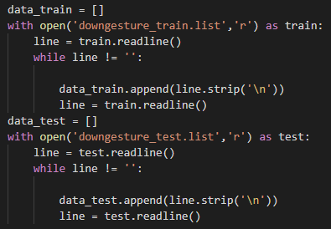

Get the list of train data and test data:

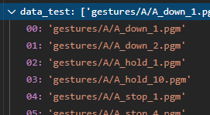

According to the list, read corresponding pgm image with PIL.image library, and reshape it to a vector for FNN. Then normalize pixel from 0 to 1. Go through all image in list.

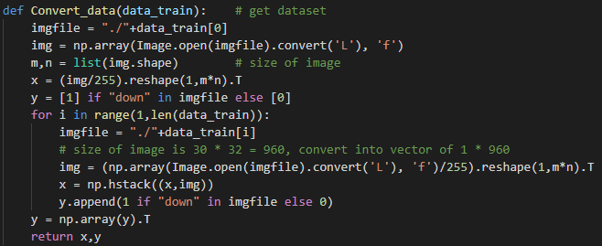

We get matrix of train data and test data with size of 960x184 and 960x83 correspondingly:



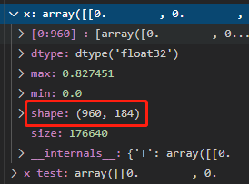

1. FNN:

The function have 5 parameters, x for training dataset, y for labels, epoch for max epoch number, hl for number of neuron in hidden layer, and ini for range of initial weight [-ini, ini].



Step 1: initialize the weight and bias between -0.01 to 0.01 for each layer:

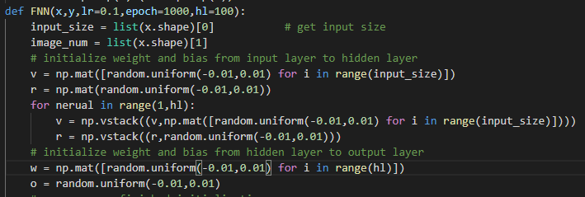

Step 2: In each epoch, read all images one by one, and compute their loss with result. Then compute the gradients based on the loss, and update weights and biases to the direction of gradients decent.

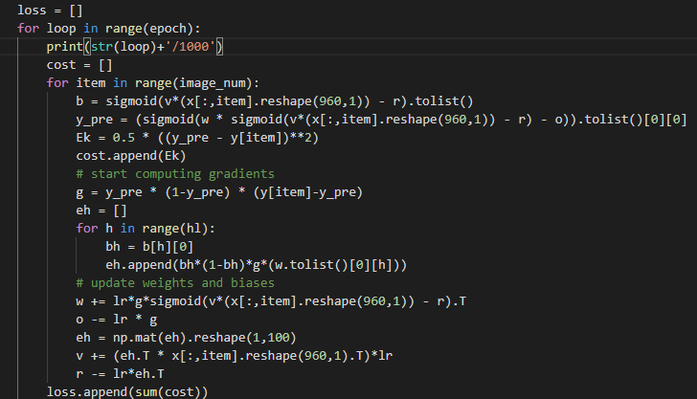

Return all weights and biases and loss record:



1. Test:

Make a prediction for test data, and compare the prediction with the label, compute the accuracy rate:

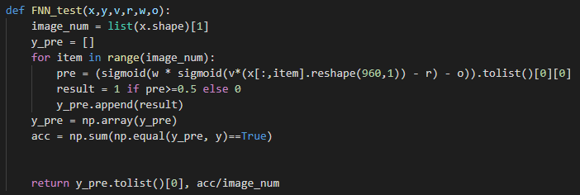

1. Optimizations
2. Use matrix operation instead of compute weights and bias for each neuron one by one, which can improve the implement speed.
3. Set learning rate, max epoch and hidden layer details as a parameter rather than hard code it. This can help debugging with different network structure.
4. Record loss in each step, can track if the function works correctly.
5. Challenges faced
6. Found that the magic num of pgm image in this assignment is P5 rather than P2, which means the content of document can’t read in txt file, and must to use PIL.image.convert() to read the pixel value.



1. Result of prediction

Run code below:

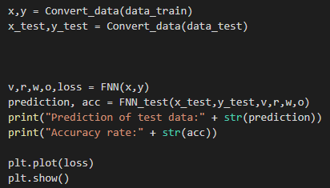

Get the result of weights and biases, and plot the loss curve:





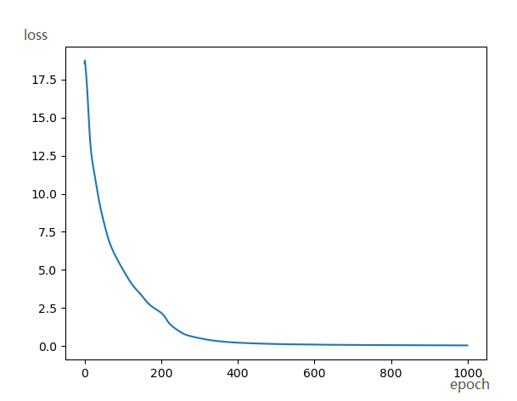

After over 10 times of test, the accuracy rate can achieve 87%-91% with different initial weights.

What’s more, I output some error predicted image, found out that they have some shadow and this shadow effects the prediction. The margin of shadow would be recognized as the finger so predicted as “up”.

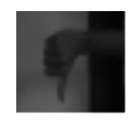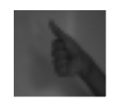

1. Part 2: Software familiarization
2. Library function: sklearn.neural_network.MLPClassifier
3. How to use: use clf=MLPClassifier().fit(x,y) to train data, then use clf.predict(x_test) to test data:

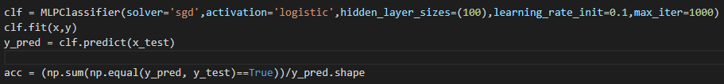

Result:



1. Comparison:
2. Difference:

The function in sklearn have more parameters can set than mine. For example, it can not only choose sgd for gradients decent, it has more choice like “adam” and “lbfgs”, which fits different data size. What’s more, it can choose activation function rather than only sigmoid in my implementation. The most important is it can build different structure of NNs. in my implementation, for time limits, I can only complete the requirement that with one hidden layer with size 100. In sklearn, you can choose any number of hidden layers.

1. Results:

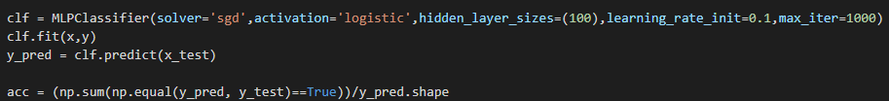







In this assignment, I can get accuracy rate of 87%-91% with different initial weights, and 89%-96% in sklearn implementation with different solver chosen. The results are similar, which can say my implementation works correctly.

1. Part 3: Applications

Neural network is one of the most popular models in artificial intelligence. It has used in our daily life widely. For example, the face recognition function in our cell phone unlock use CNN to train. Many license plate recognitions in toll gate also use CNN to recognize. Can say CNN is the most important algorithm in image recognition.